Mapol is a tech company that produces hardware, distribute to different customers, from where products get sold to consumers all over the world

Mapol also sells these products directly from their online and physical sales platform. In addition, they sell products to distributors in some country where sales to customer is either prohibited or not advantageous.

Considering this complex environment, mapol has recorded huge loss while trying to expand to some other market (North America) because they made business decisions based on surveys and intuition, therefore they decided to onboard data analytics to increase transparency and guide proper decision making across board in their organisation hoping to increase business profit thereby. The analyst team will provide an interactive dashboard that will allow different departments get respective related insight and thus make data driven decisions.

* This is an end-to-end Data analysis project that produced a report that was shared on the online power BI platform, which enable users to make a data informed decision
* Connected Power BI to MySQL, Excel to import about 4 million records. Performed data transformation in Power Query using GUI and M language.
* Other column calculations and creation of measures and parameters ware completed with DAX language in main Power BI platform
* Built dashboard in power BI from scratch for finance, sales, marketing, supply chain, and executives which will support the organisation in gross margin improvement. A special view for gross margin and deduction trend was also included.

1. The home page provided a general navigation tool to all aspect of this project.

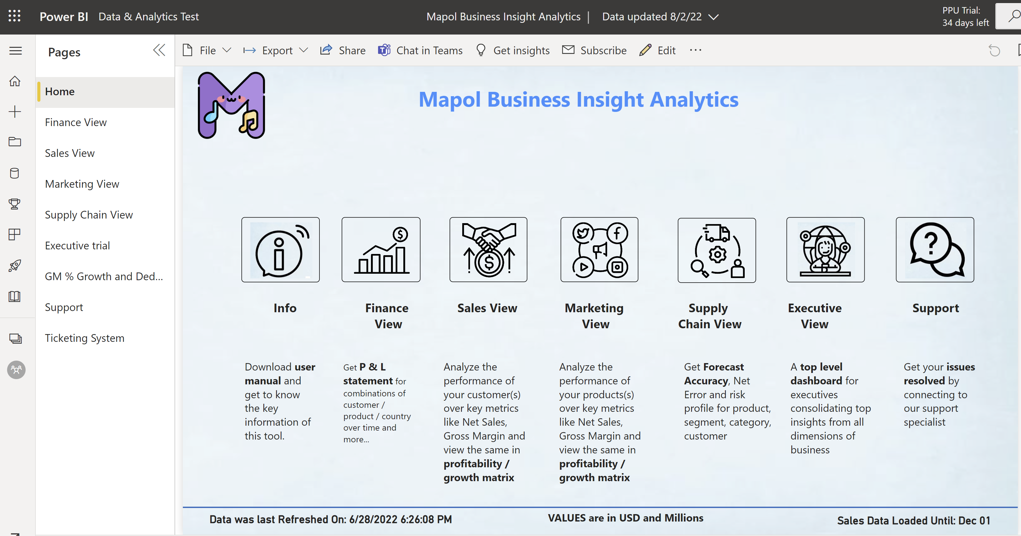

1. The finance view shows P & L Statement for the organisation with a chart showing each selected P & L parameter accurately compared with given Benchmark (yearly **Target** value or last year (**LY**) value) depending on clicked button. **This assisted the financial team to make decision that will increase values for parameters such as net sales and gross margin percentage**.

See image below:

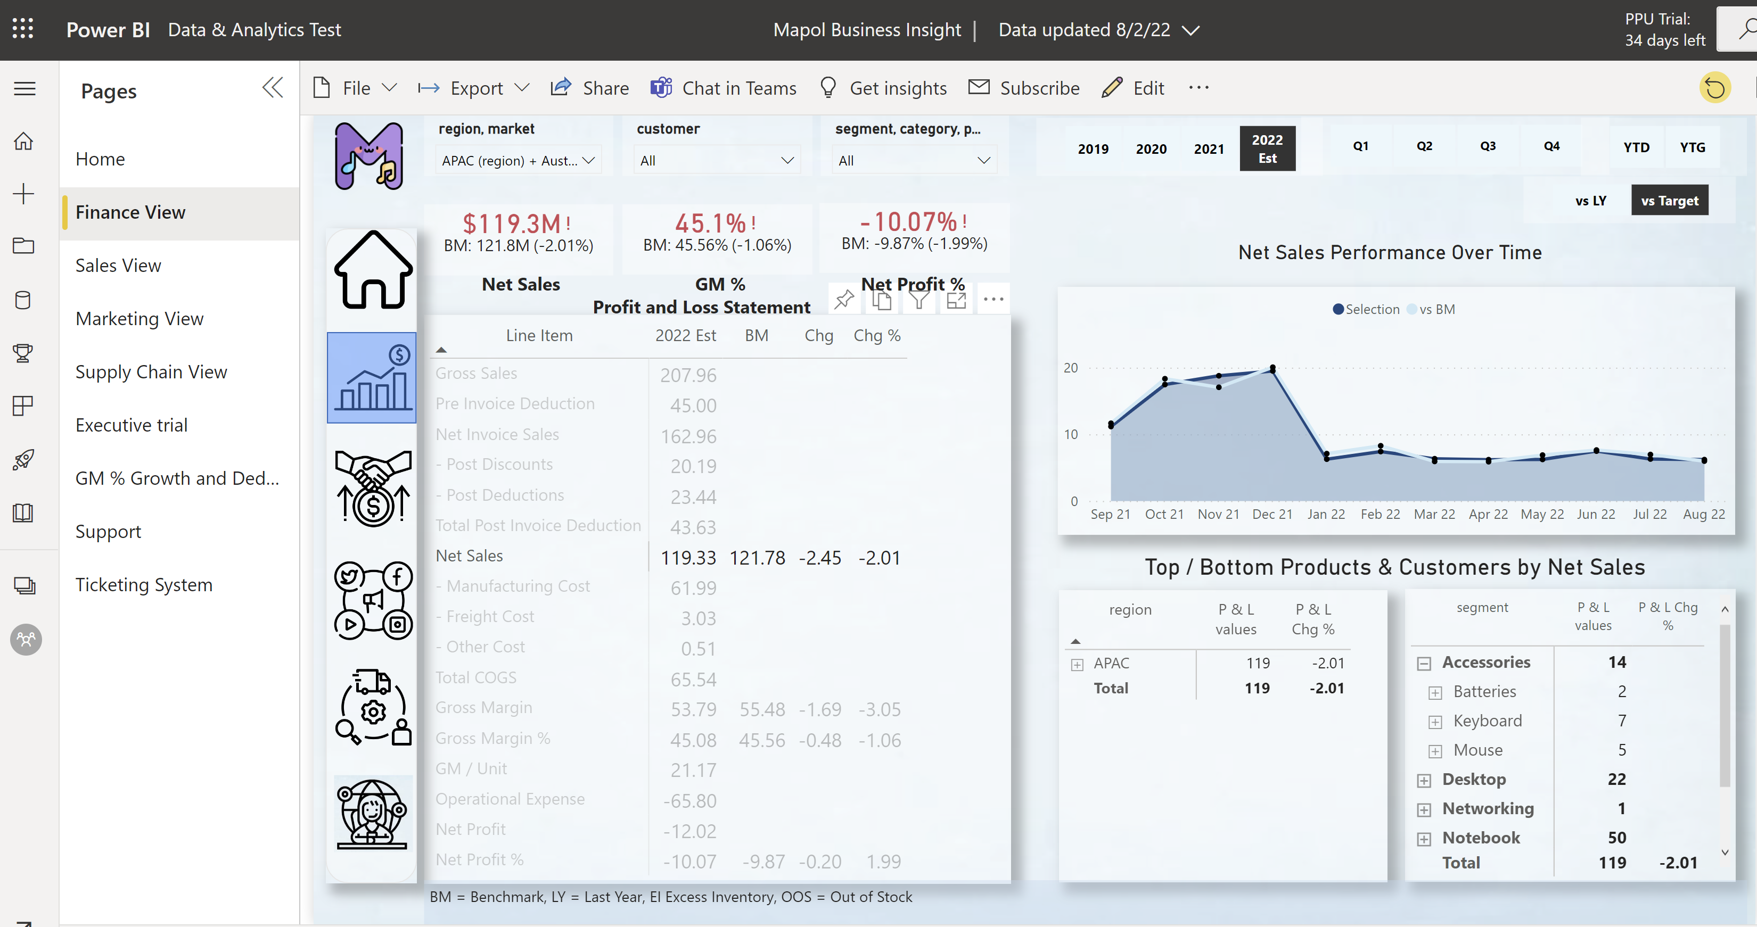

1. Customer performance was visualised using performance matrix chart which captures different region and countries as well as the deductions accrued. **Dynamically selected filters** can be applied so that customers/markets that falls below such dynamic benchmark can be easily consumed and necessary decision can be arrived at.

See image below:

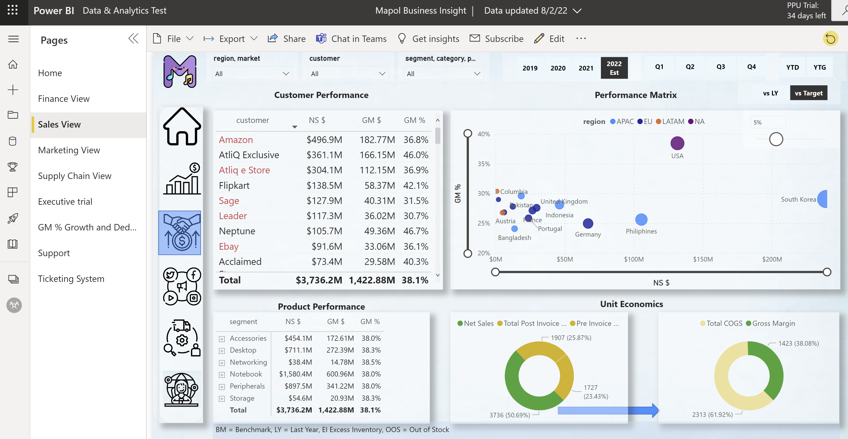

1. In the marketing view, depending on any filter selected in the page, a button can be toggled which will switch between two similar visuals to give a comparison between “Net Profit and Net Sales” on one hand and “Gross Margin and Net Sales” on the other hand. Simply put, the three most important parameter can be consumed on the fly and decision can be made accordingly.

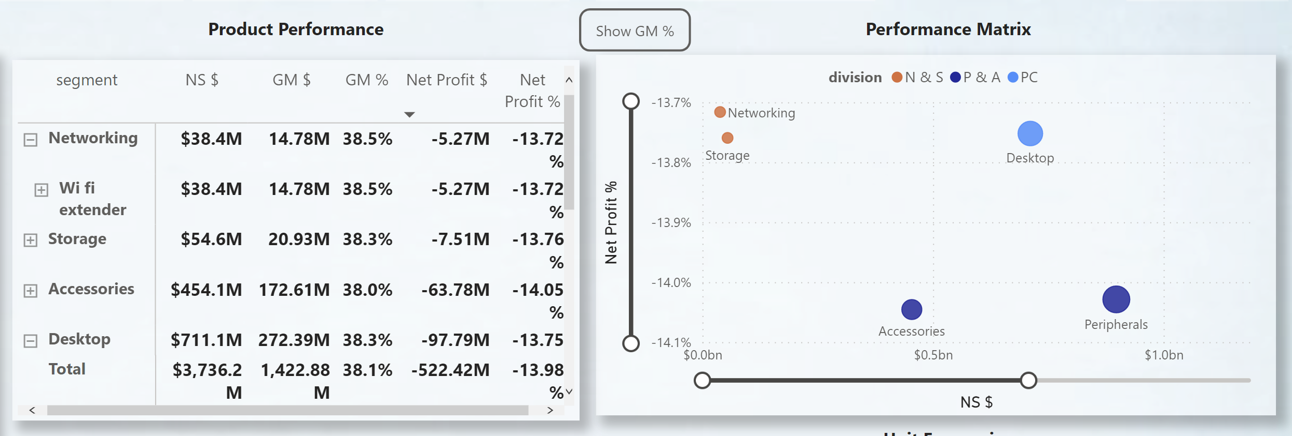

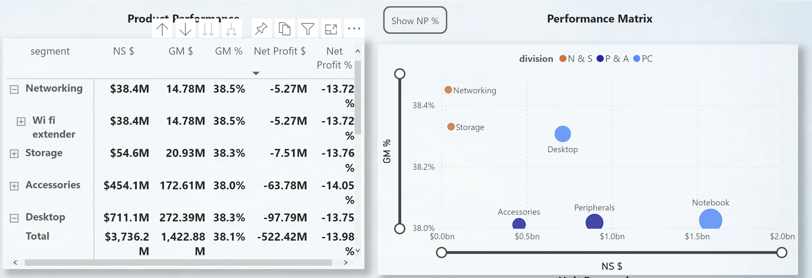

1. The executive view gives overview relating top performance, this will aid targeted approach to product/market/customers that are meeting desired benchmark on one hand and re-evaluate continuous dealings with others as necessary.

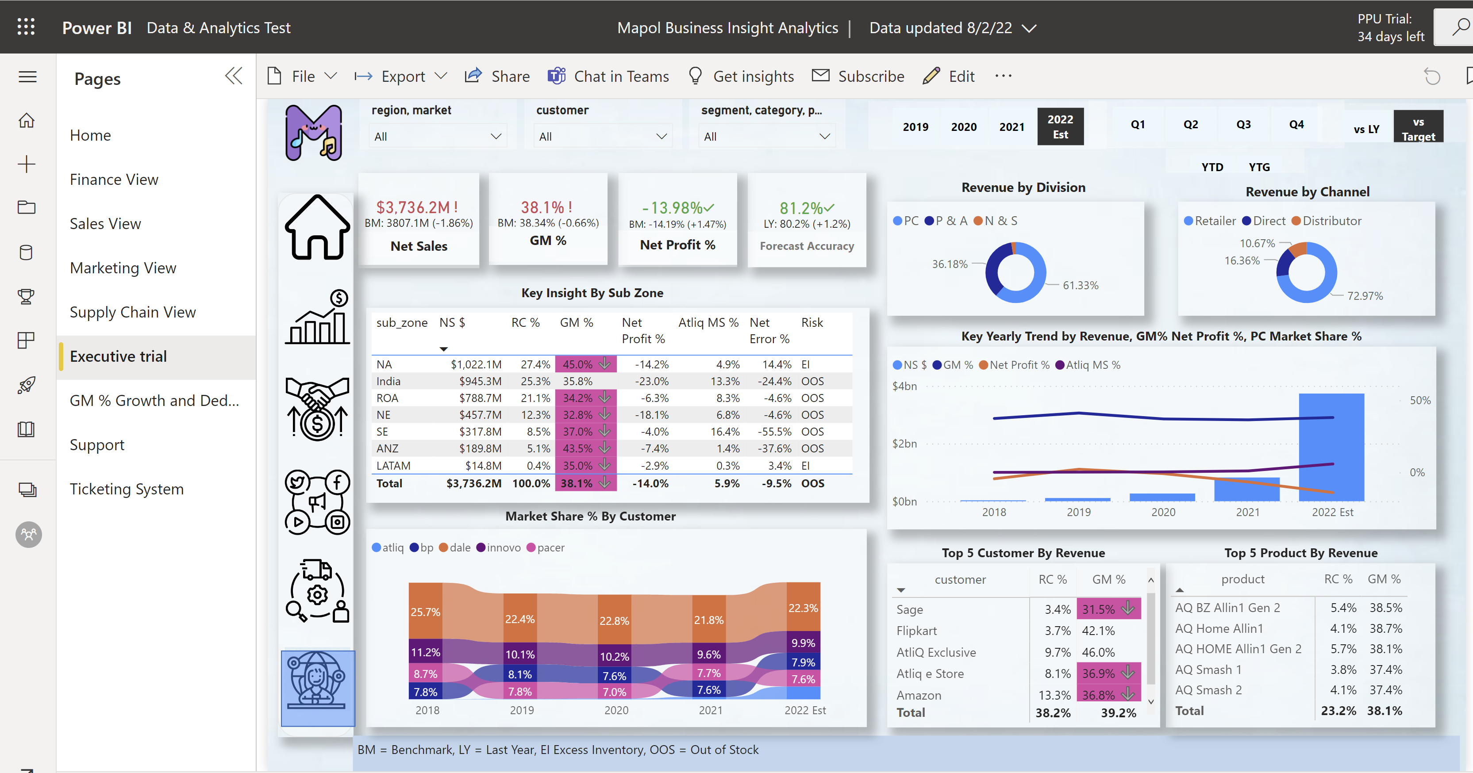

* The build Dashboard also allows granular view to understand the expenditure relating to promotion and deductions so that data driven decision can be made to facilitate net profit generation.
* Project was executed using project management skills: Project charter (Using Mural), stakeholder mapping analysis, Kanban board for task assignment to improve productivity

Conclusion:

This report provides immediate detailed insight with high degree of granularity to individual department, as well as the executives. Consequently, data guided decisions could be instantly arrived at and revenue and profit margin can be shored up.

Acknowledgement:

I appreciate codebasics.io teams for providing the data and training me through this project.

I also give appreciation to FlatIcon for providing the background and icons used in this project.

(<a href="https://www.flaticon.com/free-icons/m" title="m icons">M icons created by Freepik - Flaticon</a>)